**Name:** Rameen **Roll No:** 2023-EE-03

EE-322L Analog and Digital Communication Marks Obtained: ________

**Lab Report**

**Experiment No. 4**

**Amplitude Modul­ation**

**Note:**

* **Don’t forget to include the two rubrics tables (available at the end in this document), otherwise reports will not be graded.**
* **Copy-pasted and plagiarized reports will get zero marks**

1. **Objective**

To design and implement an **unbalanced amplitude modulator** using a nonlinear diode circuit and to observe how the diode combined with a band-pass filter produces an AM signal when a low-frequency message is added to a high-frequency carrier.

1. **Technical Background**

In amplitude modulation, we change the strength (amplitude) of a high-frequency carrier according to a low-frequency message signal. In this experiment, the message and carrier are first added together and then passed through a diode. Because the diode is nonlinear, it mixes the two signals and creates new frequency components, including the carrier and the sidebands that form the AM signal. A band-pass LC filter tuned near the carrier frequency is then used to remove unwanted extra signals, so the final output is a clean AM-modulated waveform.

1. **Task-1**
   1. ***Description***

Find the resonant frequency of the band pass filter.

* 1. ***Circuit, Design and Calculations***

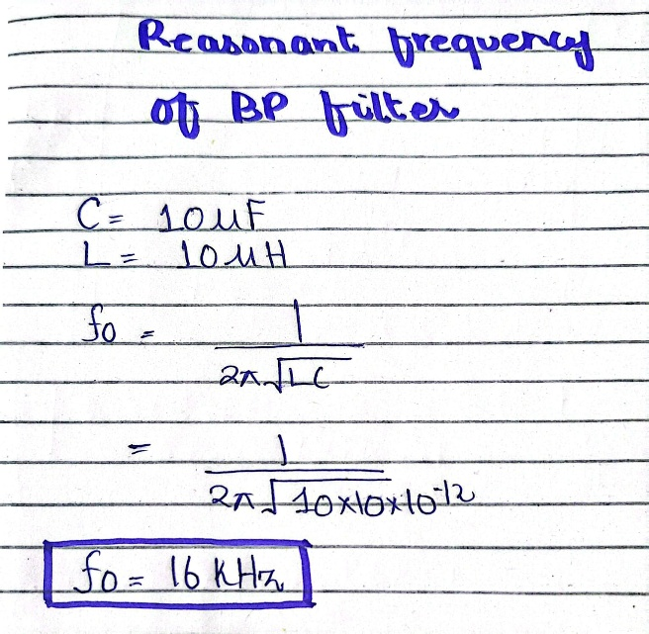The following is the calculation for the resonant frequency of the band pass filter:

* 1. ***Results and Discussions (with all graphs and snaps)***

The capacitor and inductor available in the lab were 10µF and 10µH, respectively, so the resonant frequency for the band pass came out to be 16 kHz.

1. **Task-2**
   1. ***Description***

Set the frequency of one of the sinusoidal sources to 𝑓𝑜. Will this source be the carrier or the message signal?

* 1. ***Circuit, Design and Calculation***

The following figure shows the frequency supplied to the carrier signal by the signal generator:

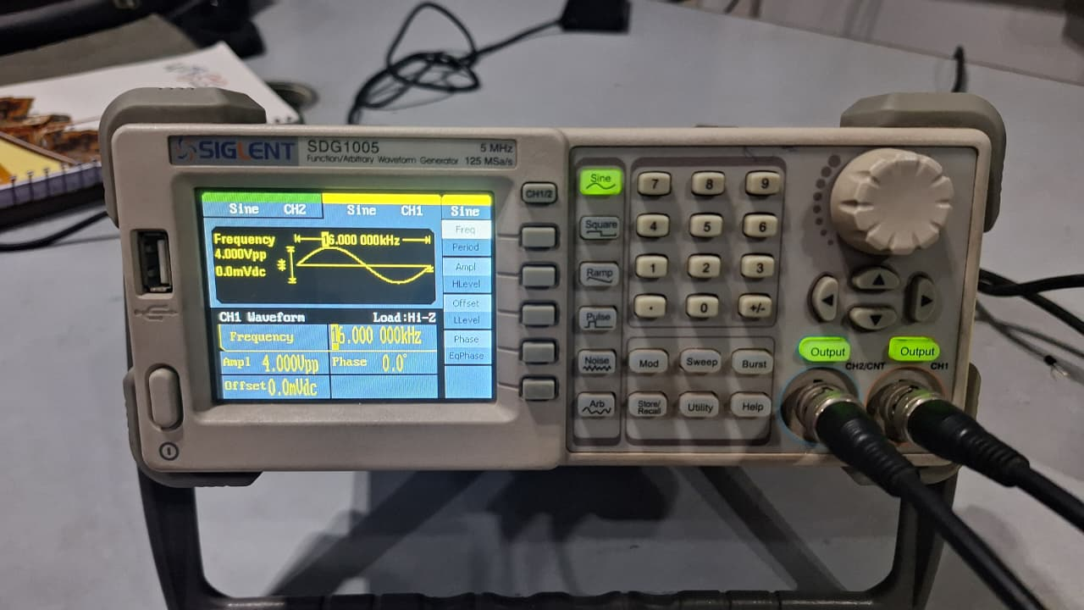

* 1. ***Results and Discussions (with all graphs, and snaps)***

The sinusoidal source set to fo ( 16 kHz) will act as the **carrier signal**, since fo​ is the higher frequency component around which the sidebands appear in the modulated spectrum. The lower frequency source serves as the message signal.

1. **Task-3**
   1. ***Description***

Set the frequency of the other sinusoidal source appropriately. i.e. if it is generating a carrier signal then its frequency is to be more than 100 times greater than the message signal’s frequency or vice versa.

* 1. ***Circuit, Design and Calculations***

The following figure shows the frequency supplied to the carrier signal by the signal generator:

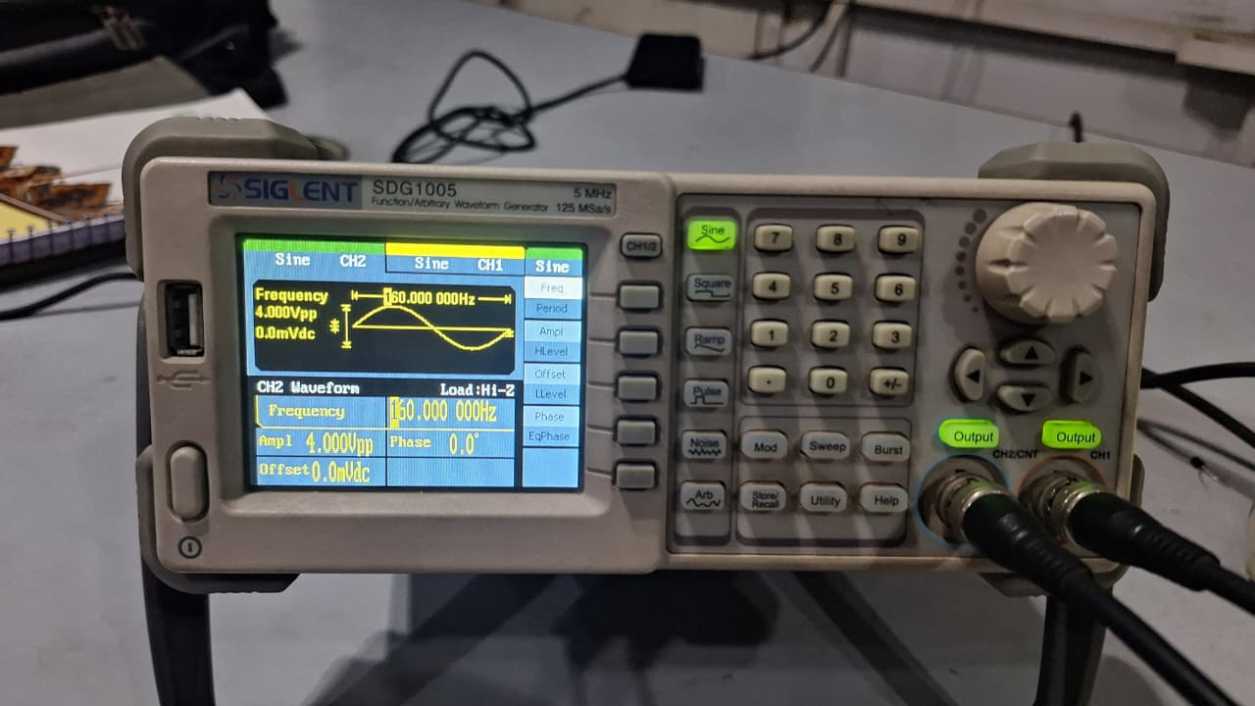

* 1. ***Results and Discussions (with all graphs and snaps)***

The frequency of message signal is set to 160 Hz because it is 100 times less than the frequency of carrier signal.

1. **Task-4**
   1. ***Description***

Implement the circuit on breadboard and observe the output. Plot the input and output signals.

* 1. ***Circuit, Design and Calculations***

The following figure shows circuit implemented on breadboard:

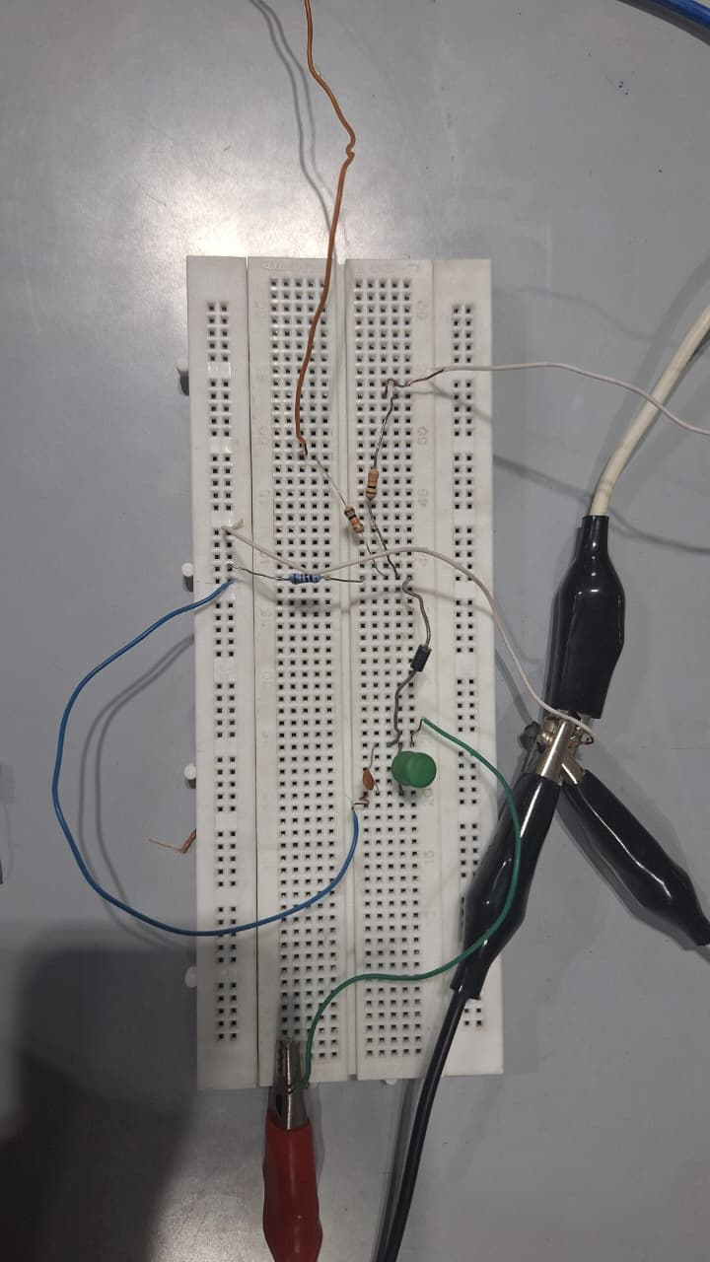

**GRD**

* 1. ***Results and Discussions (with all graphs and snaps***

**Carrier signal:**

**Message signal:**

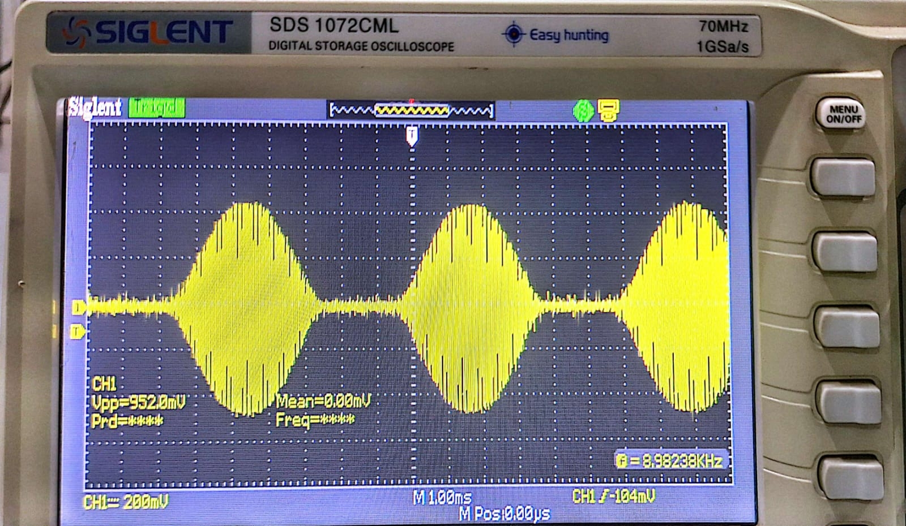**Modulated signal ( output signal ):**

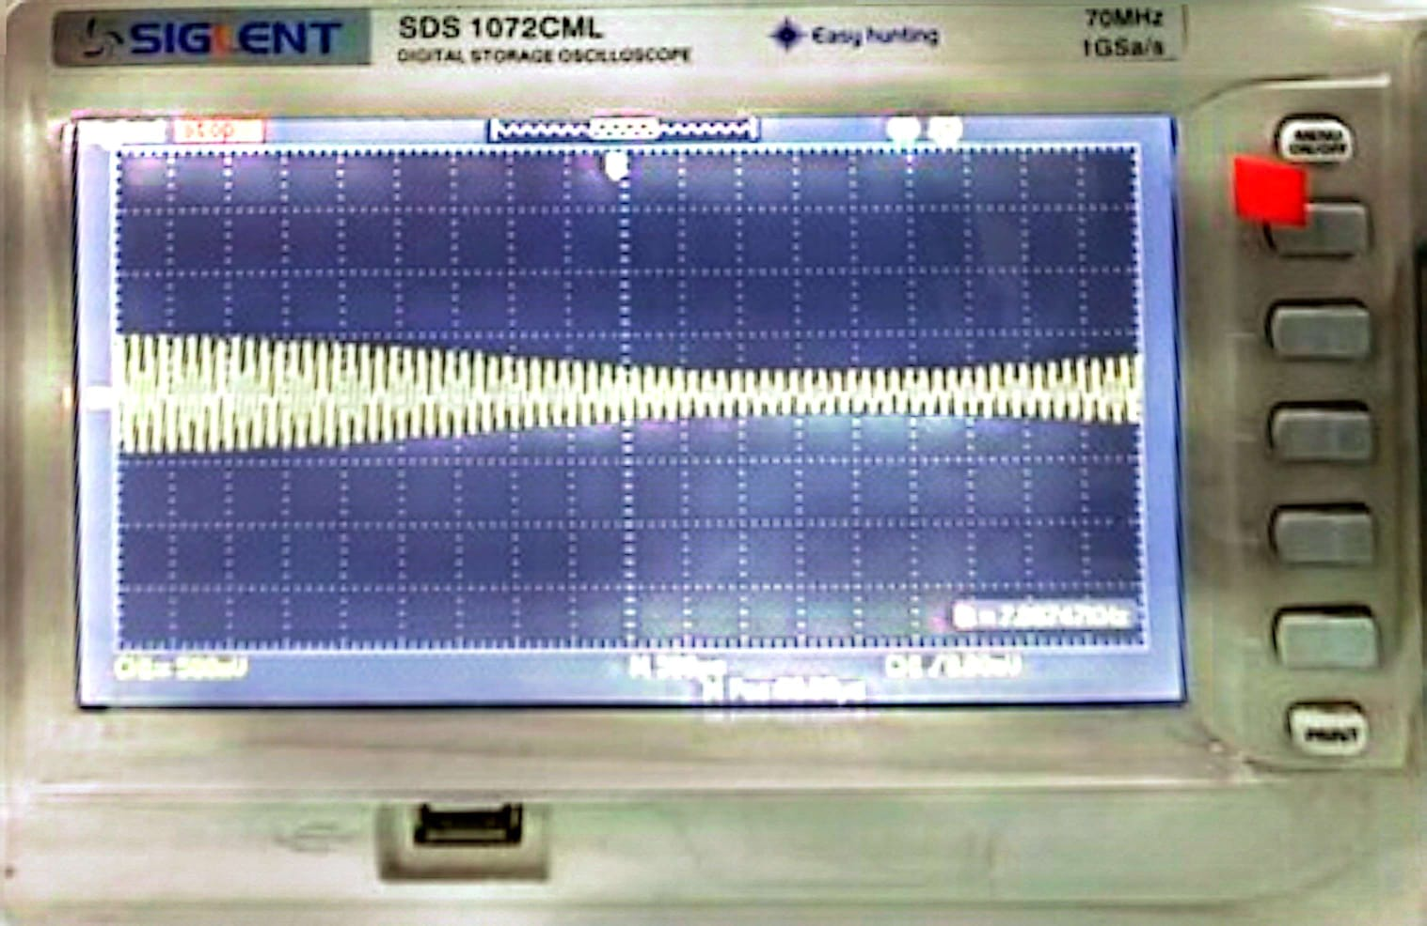

In the modulated signal it can be seen that the amplitude of the signal varies with the message signal m(t). Therefore, the message signal forms an envelope, both above and below the carrier to form the modulated signal.

1. **Task-5**
   1. ***Description***

For task in (4), explain the output waveform, the methodology and the circuit.

* 1. ***Results and Discussions (with all graphs, and snaps)***

R2 and R3 limit the current from V1 and V2 before both signals are summed at R1. The diode performs the mixing, producing the AM waveform. C1 and L1 form an LC band-pass filter that removes unwanted harmonics and only allows the carrier and its sidebands to pass. As seen in the oscilloscope trace, the output now shows an amplitude-modulated waveform , a carrier sinusoid whose amplitude is varying according to the slower message signal, indicating the presence of sideband components around the carrier frequency in the spectrum.

1. **Conclusion**

This experiment gave hands-on experience with AM modulation, using a nonlinear diode to perform the modulation and an LC band-pass filter to remove unwanted harmonics. It demonstrates that a basic AM modulator can be implemented with simple and low-cost components, especially when compared to more complex methods like FM or PM.

**Rubrics for Experiment No.**

|  |  |  |  |  |
| --- | --- | --- | --- | --- |
| **Performance** | **Exceeds expectation (2)/(1)** | **Meets expectation (1)/(0.5)** | **Does not meet expectation**  **(0.5)/(0)** | **Marks** |
| **R1: Realization of Experiment’s Hardware on Breadboard.**  **Marks: 0-1** | The circuit is patched correctly, and safely, with neat  connections on the breadboard | The circuit is  patched neatly and correctly, but not in a workable form | Incapable to patch the circuit correctly and  neatly on breadboard |  |
| **R2: Knowledge of theoretical aspects**  **Marks: 0-2** | Has theoretical knowledge required for the experiment | Has partial theoretical knowledge about the experiment | Has no background knowledge about the experiment |  |
| **R3: Conducting Hardware**  **Experiment.**  **Marks: 0-1** | All the required tasks are correctly implemented | The required tasks are partially implemented | Unable to implement all the tasks even with guidance |  |
| **R4: Demonstrate proper results with justification.**  **Marks: 0-2** | Correct results are provided with required justification | Results are provided with  minor errors and/or with little  justification | Results are provided with major errors  and/or with no justification |  |

**Rubrics for Lab Manual No.**

|  |  |  |  |  |
| --- | --- | --- | --- | --- |
| **Performance** | **Exceeds expectation (0.5)/(0.25)** | **Meets expectation (-)/(-)** | **Does not meet expectation (0)/(0)** | **Marks** |
| **R1:** Timely submission  **Marks: 0-**  **0.25** | The submission is on  time | --- | Late submission |  |
| **R2:** Report completenes s  **Marks: 0-0.5** | All relevant calculations, specifications, code, graphs, and results are provided with proper  explanation. | All the relevant calculations,  specifications, code, graphs and results  are provided but with little  explanation and justification. | Most of the relevant graphs, results,  calculations, specifications, and code are missing, as well as their proper  explanation and  justification is also missing. |  |
| **R3:** Error-  free writeup  **Marks: 0-**  **0.25** | The submitted  assignment is without any plagiarism and formatting errors. | Some parts of the submitted  assignment contain formatting errors and plagiarized material. | The submitted assignment is mostly plagiarized and contain formatting errors. |  |